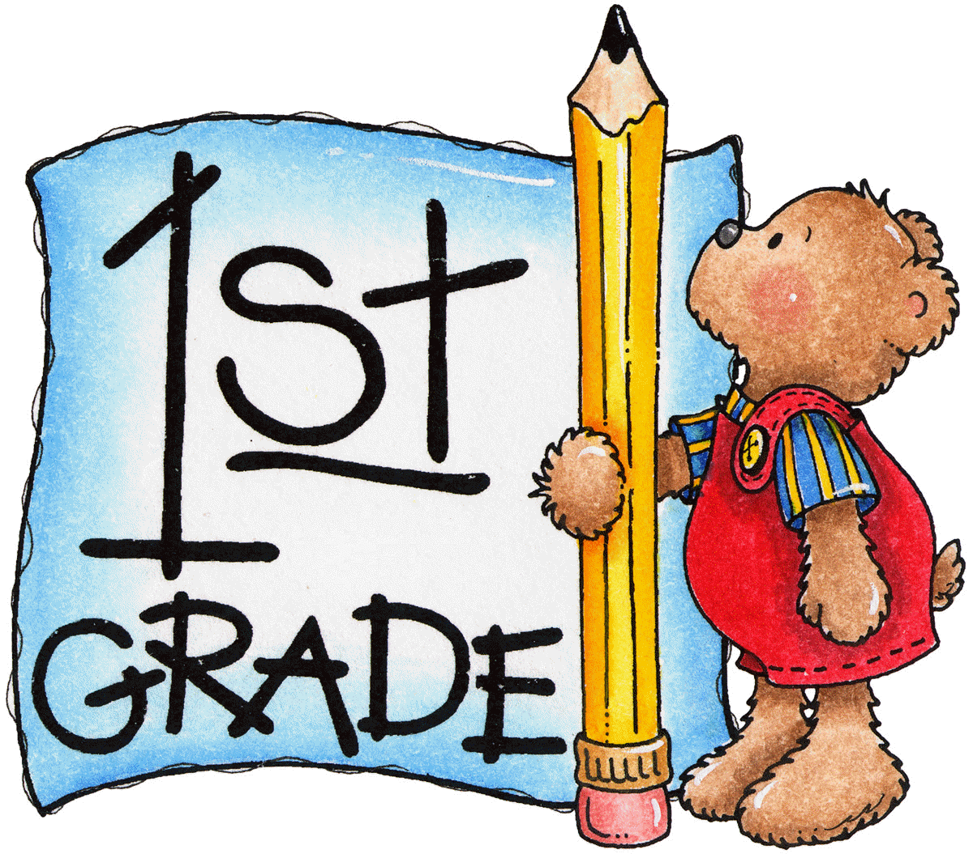
News
Important Reminders:
- Great start to first grade!
- Please remember to return all paperwork from your child’s folder.
- Please make sure your child is on time for school. Academics begin at 7:45 a.m.
- If your child’s transportation changes, please send a note or call the school before lunch time. Please do not email the teacher because sometimes your child’s teacher may not check emails until the end of the day.
- Your child may bring a snack from home to have at our 2nd recess time. Please remember no peanuts or anything that contains peanuts for lunch or snack! Thank you!!!

Reading/Language Arts  Your child will begin a story called Hoorah for Snail Written By: John Stadler  Your child will be able to identify that this story is a fantasy. We will be working with the following letters: b,m,r,s  Your child will be able to identify words that begin with these letters as well as work on handwriting by practicing letter formation. | Math  We will be starting our math program, enVision Math this week. In topic 1, Understanding Addition is a review on spatial patterns for numbers to 10, making 6, 7, 8, and 9, addition expressions, and problem solving. Your child will also be assessed on basic math facts. Please look for the letter that explains the addition facts your child will be tested on as well as dates for the assessment.
Science/Social Studies  We are continuing to work on how to be a good citizen by following rules and having responsibilities. | 