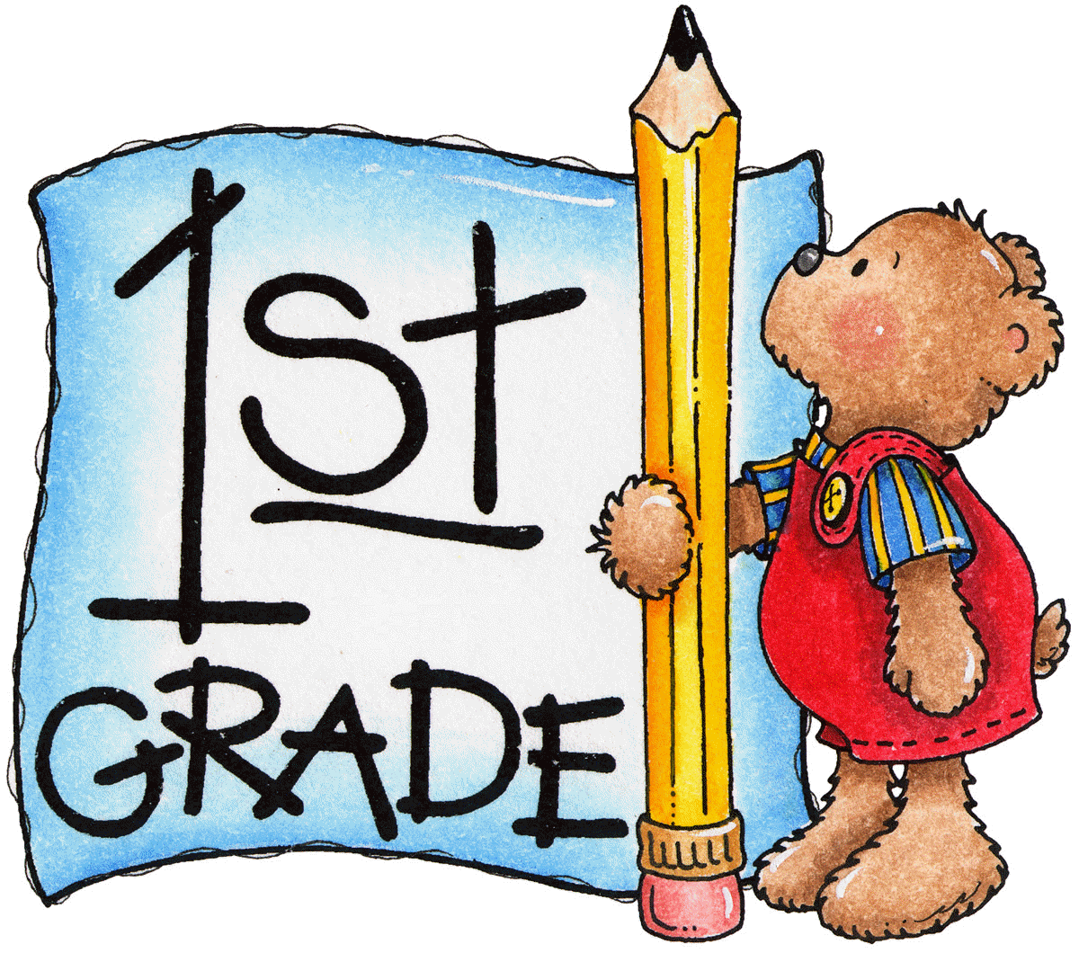
Week of: August 14th
News
Important Reminders:
- Please make sure your child is on time for school. Academics begin at 7:45 a.m.
- If you are picking up your child, please wait across the street until all classes in all grade levels are in place on the sidewalk before you cross to get your child. This is a safety concern.
- If your child’s transportation changes, please send a note or call the school before 1:00 p.m. Please do not email the teacher because sometimes your child’s teacher may not check emails until the end of the day.
- Your child may bring a snack from home to have at recess time. Please remember no peanuts or anything that contains peanuts for snack! Thank you!!!

Reading/Language Arts  Our story this week will be Soccer Game By: Grace Maccarone  We will be working on the following sounds and practicing the letter formation of a, t, n, and g. Please help your child to identify these sounds at the beginning, middle, and end of words.  IMPORTANT: Please see parent letter regarding Fry List 1-50. | Math  We will continue working on simple addition. Remember to quiz your child on Math Facts Set 1 sent home last Friday. The test will be Tuesday, August 15th.
Science/Social Studies  We are continuing to work on being a good citizen in social studies. We are also exploring magnets during Tiger Time. | Language/Spelling  Your child writes daily in their notebook and journal. In notebooks, a dictated sentence is written and in journals they write a response to literature from our weekly story. Therefore, we focus a great deal on how to write a sentence correctly.  Your child will begin to have spelling tests in a few weeks. This Friday, your child will be assessed on writing the first 13 letters of the alphabet in lower case. (a-m)

